RESOLUTION NO.__________

RE: CERTIFICATE OF APPROPRIATENESS UNDER THE
PROVISIONS OF THE ACT OF THE PENNSYLVANIA
LEGISLATURE 1961, JUNE 13, P.L. 282 (53
SECTION 8004) AND BETHLEHEM ORDINANCE NO.
3952 AS AMENDED.

WHEREAS, it is proposed to repaint the front of the building at 512 Main St. (Jewel Werks).

NOW, THEREFORE, BE IT RESOLVED by the Council of the City of Bethlehem that a Certificate of Appropriateness is hereby granted for the proposal.

Sponsored by: (s)

(s)

ADOPTED BY COUNCIL THIS DAY OF

(s)
President of Council

ATTEST:

(s)
City Clerk

HISTORICAL & ARCHITECTURAL REVIEW BOARD

The applicant proposes to repaint the façade at 512 Main St.
(Jewel Werks).
APPLICATION #2:

David Velho
1778 Arden Lane, Bethlehem, PA 18018

OWNER:

__________________________________________________________________________

The Board upon motion by Gen Marcon and seconded by Marsha Fritz adopted the proposal that City Council issue a Certificate of Appropriateness for the following:

- The store doors and upper story will be painted Benjamin Moore
Atmospheric #AF-500 Affinity.

- The storefront spandrel and panels below the windows will be Benjamin Moore
OC-13 Soft Chamois.

3. The cornice and raised moldings around the sign panel, the trim around the
windows and on the panel moldings below the windows will be Benjamin Moore
Annapolis Gray.

4. The raised lettering will remain Black.

5. The motion was unanimously approved.

__________________________________________________________________________

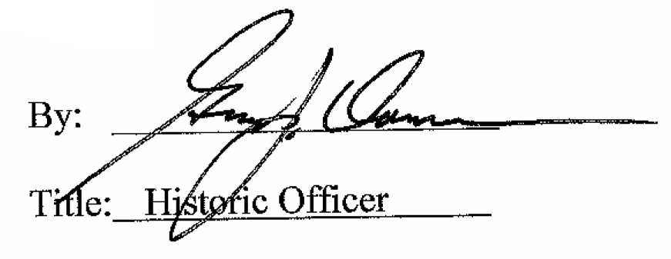

Date of Meeting: August 5, 2015

